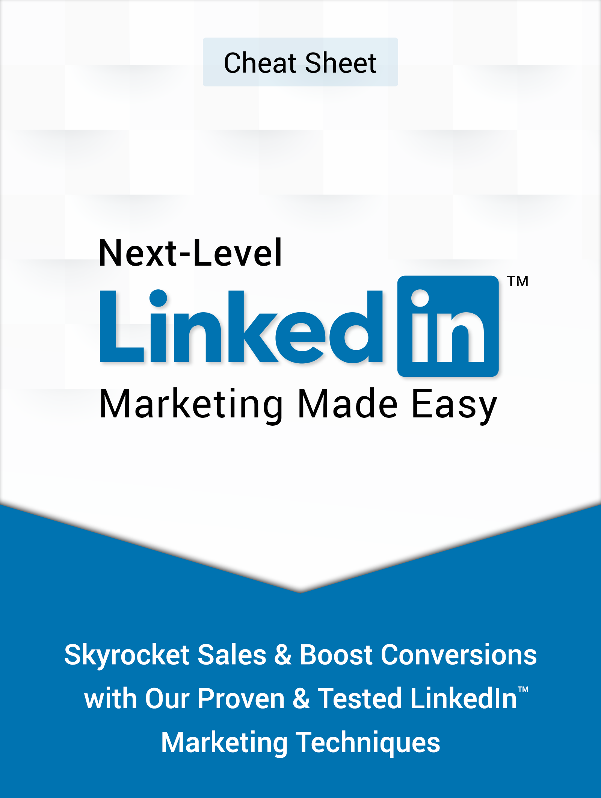

Powered By “Your Website URL here”

Limited Special Offer
Next-Level Linkedin Marketing
(HD Video Course)
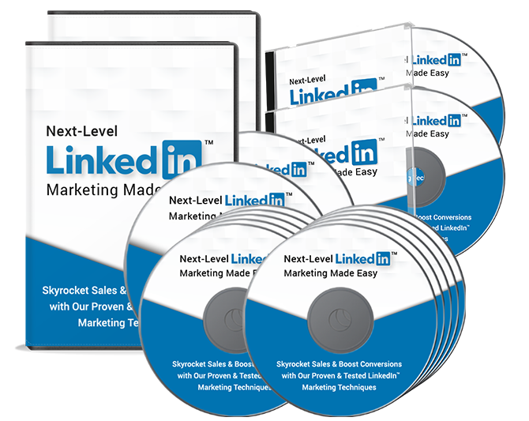
Click Here to Download Your Video Training!
(Insert your Upsell Offer URL)
The Perfect Step-By-Step Linkedin Marketing Plan For 2020  - Step 1 – Define Your Marketing Goals  - Step 2 - Create AND Optimize Your Profile  - Step 3 - Create AND Optimize Your Company Page  - Step 4 – Grow Your Audience  - Step 5 - Create And Publish Original Content  - Step 6 – Sponsor Your Content And Create Ads  - Step 7 – Analyze Your Performance  Tips For Creating Awesome Linkedin Native Content In 2020  - Start By Making Sure Your Content Is Set Up For Maximum Distribution  - Analyze Interactions And Comments  - Focus On Headlines And Cover Images  - Write About Industry-Sensitive Topics  - Give Career Related Insights And Advice  - Push Native Articles Through Posts  Powerful InMail Strategies That Work In 2020  - Composing An InMail Message  - Use Personalized Templates  - Add Calls To Action To Trigger The “Next Step”  - Send Your InMails At The Right Time  - Send InMails To Users That Have A Certain Degree Of Connection With You  Linkedin Marketing Don’ts  - Don’t Be Off Topic  - Don’t Join Irrelevant Groups  - Don’t Over Promote  - Don’t Be Pushy  - Don’t Argue  - Don’t Be Generic  - Don’t Send Random Requests  - Don’t Send Mass Messages Without Personalization  - Don’t Do Unrequested Outreach Outside Of Linkedin  - Don’t Advertise Irrelevant Stuff | Simple Linkedin Marketing Hacks To Grow Your B2B Audience  - Comment On Relevant Content  - Produce Rich-Media Posts  - Add Your Custom Linkedin URL To Email Signatures  - Host Live Events  - Encourage Staff Networking  How To Make The Linkedin Algorithm Work For You In 2020  - Publish Question-Based Posts  - Post Time-Sensitive News  - Post Infographics  - Post Stuff About Your Employees And Staff  - Cover Events  - Tag Companies And Other Users In Your Posts  - “Like” and Comment On Industry Content  Linkedin Marketing Do’s  - Set A Content Marketing Plan  - Be Active  - Get Endorsed  - Proof Read Everything  - Use Video To Build Awareness  - Use Simple Language  - Personalize Connections  - Reply Fast  - Monitor And Optimize  - Be Mobile Ready  Linkedin Marketing Premium Tools And Services To Consider  - GrowthLead  - Crystal  - LeadFuze  - SalesLoft  - Voogy  - eLink Pro  - Discoverly  - Guru  - Sales Navigator for Gmail  - Dux-Soup  Linkedin Marketing Success Stories  - DOCUSIGN  - Eurex  - PostcardMania  - Schneider  - Wild Apricot  - Callaway Golf  - IBM  - UPS  - Vestas  - Maetz Resume Consulting

